Hi Dennis,

As spoken a few days ago, kindly assist to solve for the followings:

- Amendment of Xango Delivery Order Invoice (Removed the :”Total Delivery Charges”) 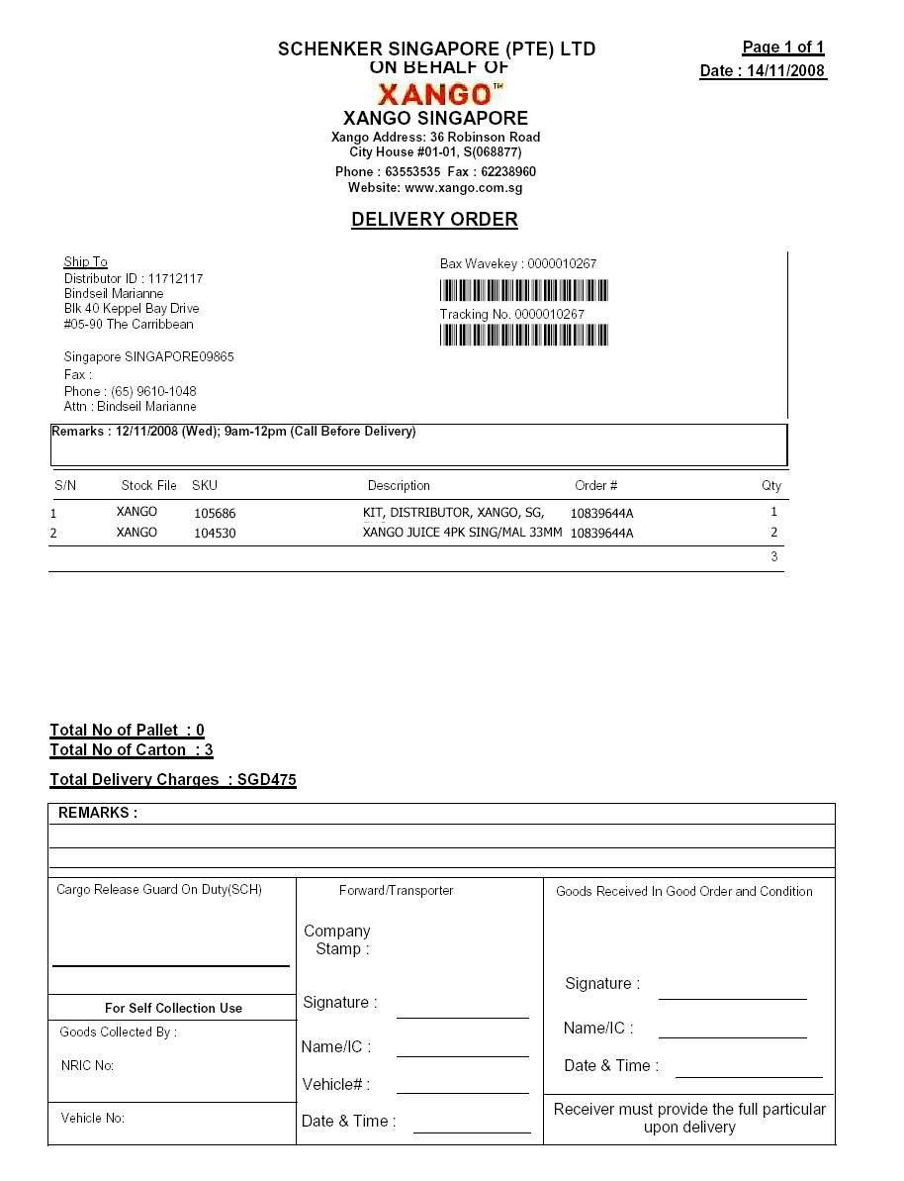
- Xango: Default the “Description” same as the wavekey#. 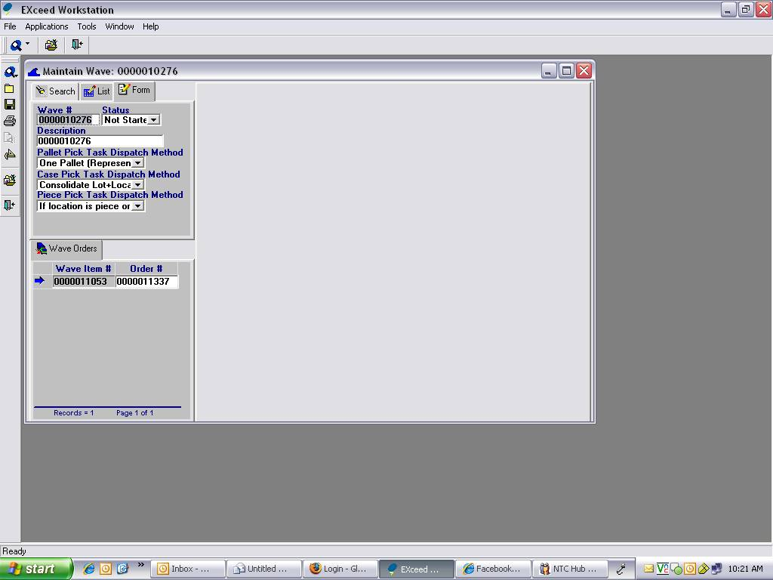
- Xango Messaging (940, 945) :“Messaging on 'samsungloanpcXango' (X)” able to be shared and run on Ming Choo, Shiow Ling and Maslinda PCs.
- Kindly assist on ASR#2336 raised by Ming Choo on 9 October 2008 for Infocus.
- Implement Xango WMS on Ming Choo and Shiow Ling PCs.
- Change name from Xangosteen to Xango in report in WMS. 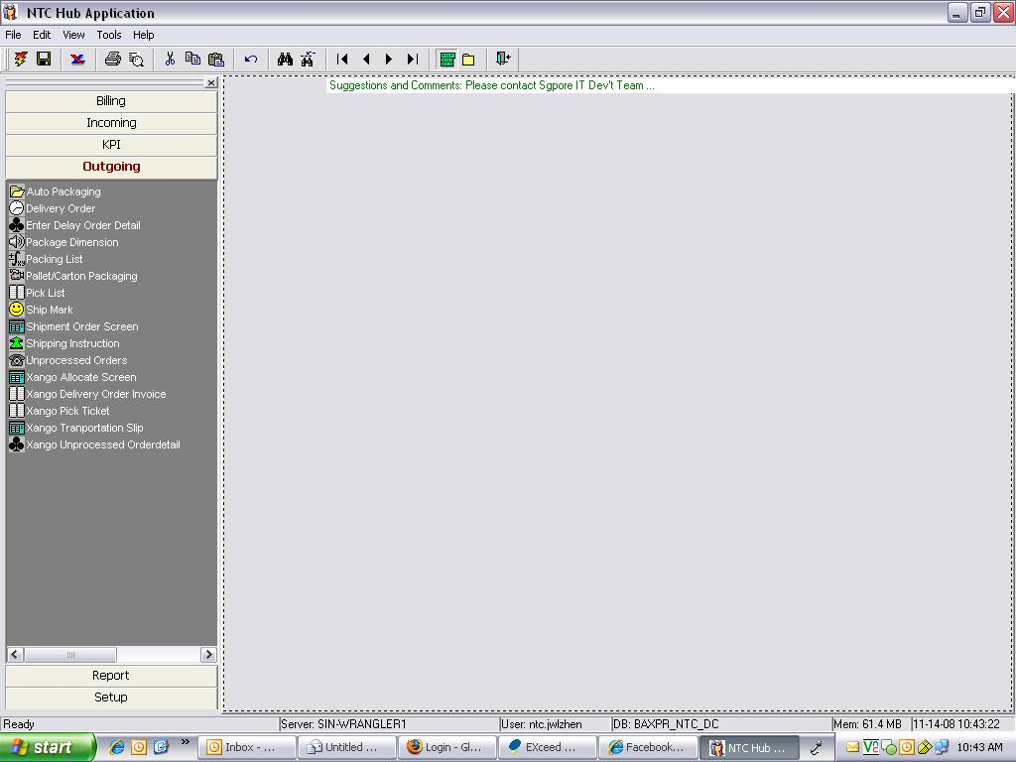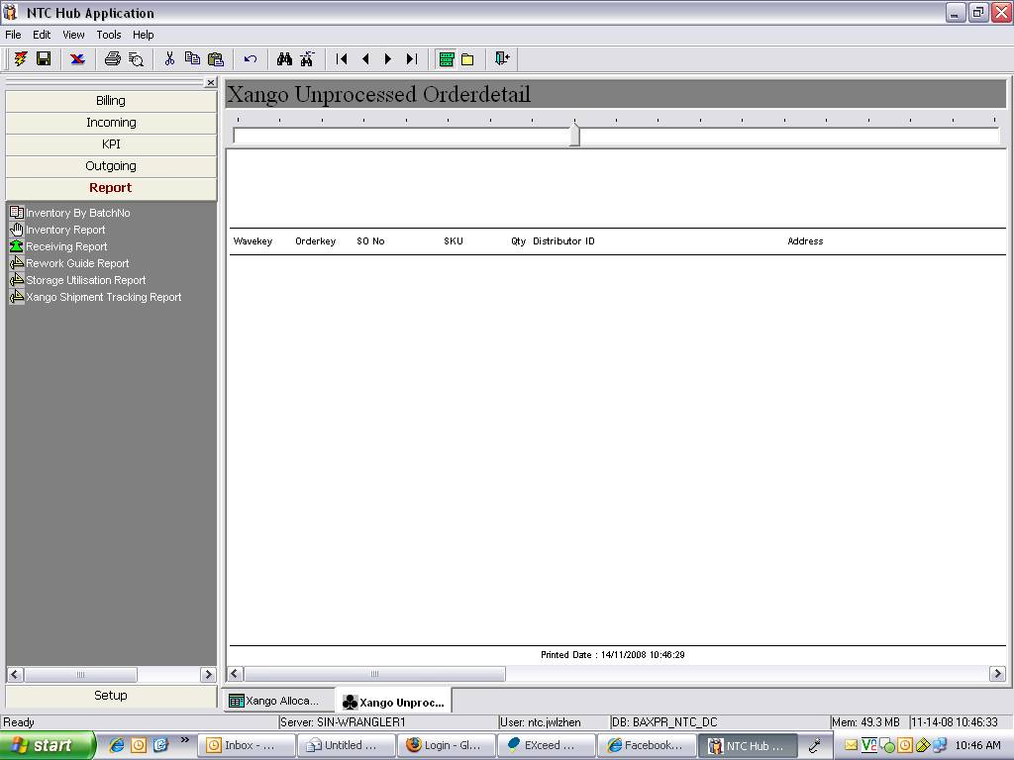
- Solving Infocus WMS Auto Updated on Maslinda PCs.
- Implementing Infocus WMS on Jane’s PC.
- Change Xango Logon ID from: “ ntc.jwlzhen “ to “ ntc.jwang “
- Create a screen for LGI01 for edit packing.

Thank you.
Have a nice day ☺

Best regards,
Jane Wang (Ms)
Logistics Officer
CLC Multi-Client
E-mail: janelz.wang@schenker.com
Schenker Singapore (Pte) Ltd
C&P Changi Districentre
3 Changi South Street 3, Level 5
Singapore 486351
Tel: +65 6545 9788 DID: +65 6549 1106
HP: +65 9029 8068 FAX: +65 6545 0107
Website: http://www.schenker.com.sg/
Disclaimer: http://www.schenker.com.sg/En/disclaimer.htm

